# Section I: Research

## 1. Introduction

This is a client-based 3D animated advertisement project for the company called ‘Griptz Tech’. This project is being made to promote their business and communicate to viewers about what they do which are web designing, mobile app development, marketing survey and software maintenance.

This animation will take viewers to an interesting journey of 3D animation scenes, each one showing the service they offer. From website wireframes transforming into vibrant, user-friendly design to holographic charts representing data analytics. The advertisement will take place in an office like room that that symbolizes professionalism and innovation.

The main goal is to make an interesting and visually engaging advertisement that not only informs about the services but also inspires other businesses/clients to work with the company. By clearly demonstrating the company strengths. This 3D animation will also help bring in new clients, improve the brand identity, and establish the company as leader in tech industry.

## 2. Literature Review

To make this project successful there are lot of theories that goes into detail. For the advertisement of this company, theories should align with technical innovation, trustworthiness while appealing to target audience such as businesses, tech-savvy individuals, or entrepreneurs.

### 2.1 Emphasis in 3D Advertisements: Role of Modelling, Colour Theory and Compositing

The use of 3D in advertising has revolutionized how brands communicate with their audience, offering realistic visuals and dynamic storytelling that captivate viewers. By integrating techniques such as modelling, colour theory, and compositing, 3D advertisements make experiences that are visually stunning and remembered, which helps them stand out in crowded markets. (Sharma, n.d.).

Modeling plays a foundational role in 3D advertising by creating three-dimensional representations of objects, characters, and environments. Clean topology is essential for achieving smoother animations and realistic visuals. Techniques like edge loops, proper polygon distribution, and UV unwrapping ensure high-quality rendering and seamless movement, which are particularly important in detailed and dynamic animations. (FutureLearn, 2022). (McCallum, 2024).

Color theory gives ads more emotional depth and better visual balance. As a blend of art and science, it provides guidelines for selecting and combining colors to evoke specific feelings and draw attention. Color palettes not only enhance the overall aesthetic but also strengthen brand identity and create a polished, professional look. (Kozik, n.d.).

Texturing and Lighting further enhance the realism and mood of 3D advertisements. Texturing adds surface details like patterns, colors, and material properties, while lighting simulates natural light interactions, highlighting key features and setting the tone. Together, these elements create depth, atmosphere, and visual appeal, making the advertisement more engaging and impactful. (Shahbazi, 2024). (Katatikarn, 2023).

By using all of these methods together, 3D advertising not only gets people's attention but also leaves a lasting impression on viewers. This creative method helps brands communicate their message effectively, creating a powerful connection with potential customers.

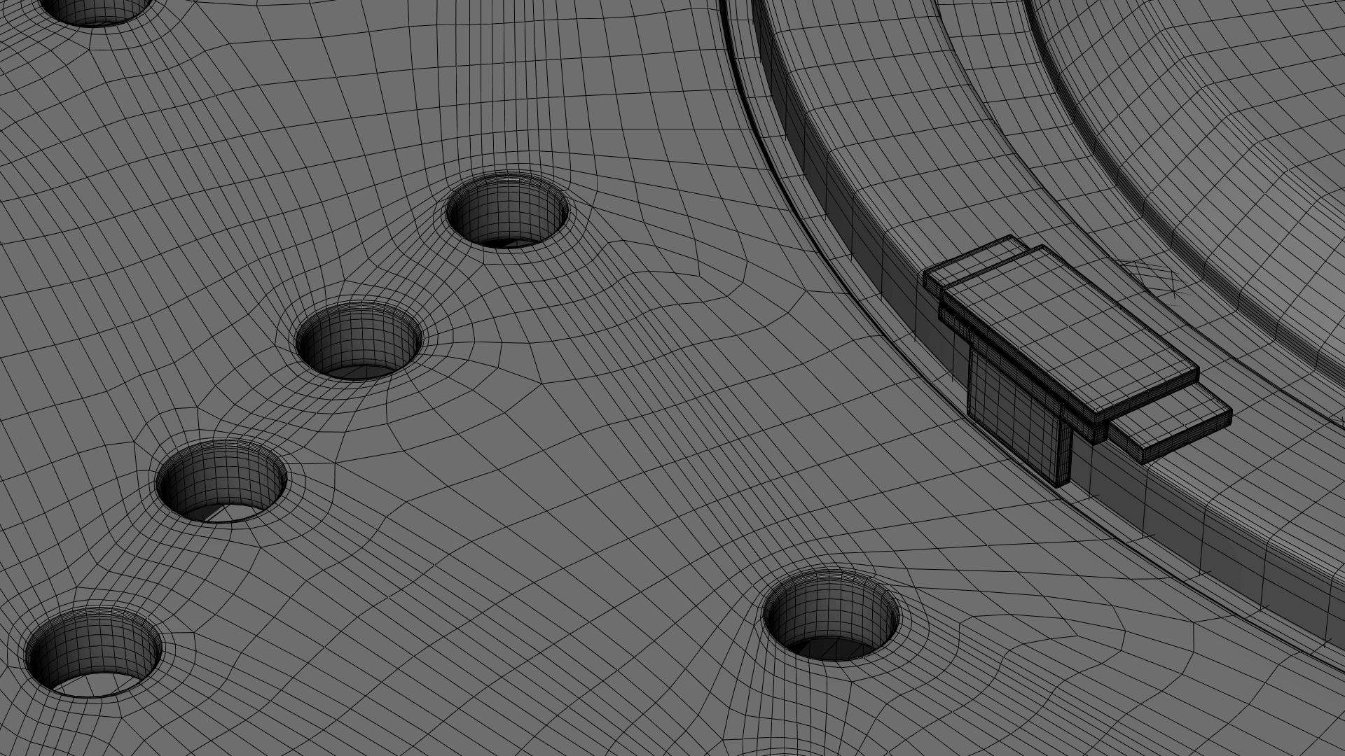

Figure 1: Reference image of Topology. (topologyguides, 2019)

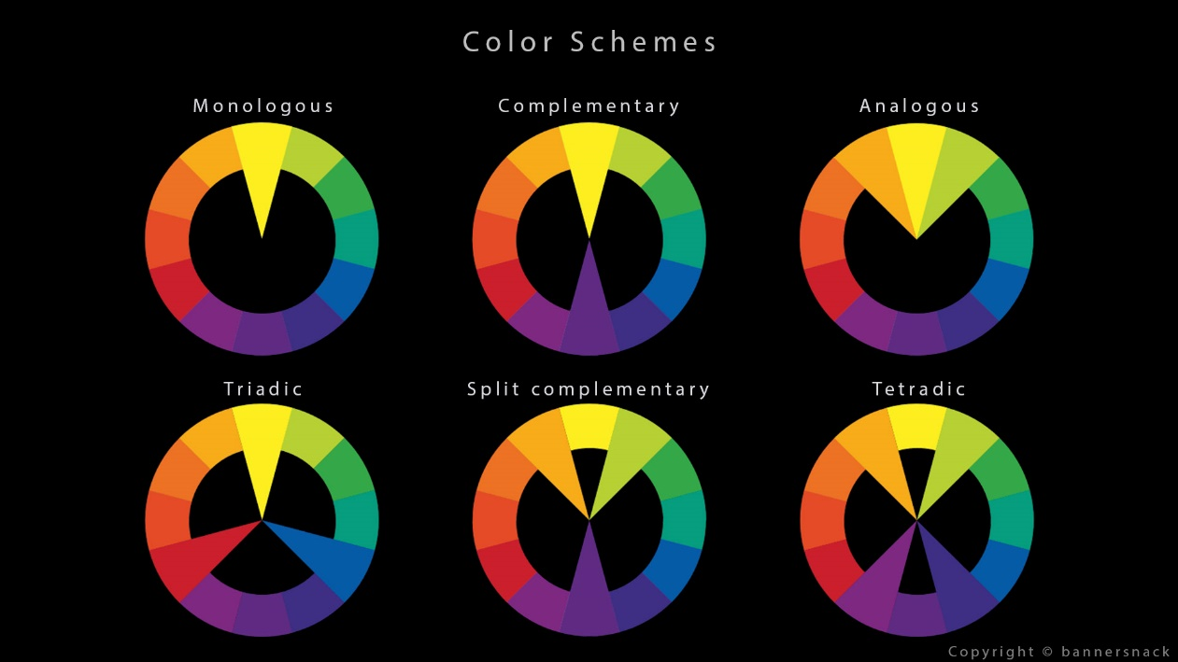

Figure 2: Reference Image of Color Theory. (Brejon, 2020).

Figure 3: Reference Image of Texturing and Lighting. (Figueroa, 2023).

### 2.2 AIDA Model (Attention, Interest, Desire, Action)

Figure 4: AIDA Model. (Hanlon, 2023)

AIDA model is a framework for converting strangers into customers. It outlines the steps process of the customer decision-making process which are Attention, Interest, Desire Action.

**Attention**: Like any pickup line, the content needs to start with something interesting. Considering what your audience or customers care about and will grab their attention immediately. By knowing about their background, business problems, goals to find out what they want to hear from you. (Tallent, 2024)

**Interest**: Once you have their attention, you build interest by explaining what the product or service is and how it addresses the viewer’s needs. By finding out answers to these questions like Why do they want to keep watching the video? What is that about voice or animation that makes viewers not skip it? This might involve showing the product’s features in a unique way that meets viewers’ needs. (Tallent, 2024)

**Desire**: Now that your audience is interested and hooked, next is changing their interest into desire. By giving them something that they really want. Making an offer and explaining how it will help them and its benefits. (Tallent, 2024)

**Action**: Finally, making the viewers take immediate action, whether it’s contacting a company, signing up for a service, or exploring their website. The action button must be simple otherwise it will confuse viewers to take action because of too many options.

(Tallent, 2024).

### 2.3 Sound Design and Voiceover

Businesses can connect with customers on an emotional level by using music, voiceover and sound effects. These can evoke feelings that are stronger than those caused by visual or written elements alone. Sound also helps brands stand out by giving them a unique voice that strengthens their identity and makes them more recognizable, setting them apart from rivals. This makes it a more natural and interesting way to get people's attention. There are different ways for businesses to use sound and voiceover, based on what they want to do, like increase sales, build a brand, reach their target customers, or achieve other goals. (D'Angelo, 2024).



Figure 5: Coca-Cola Ad. (campaignsoftheworld, 2019).

### 2.4 Human Psychology in Advertising

Human Psychology is a very important part of advertising because it affects how people see, understand, and react to words. To connect with people more deeply, advertisements use psychological techniques like emotional connections, visual assumption, and social proof. Colours play a big role on how human brain thinks about colours, red can spark excitement or urgency, while blue builds trust and calmness. Adding small things like showing limited time offers, makes people feel like they need to act immediately. (Ryan, 2024).

As David Ogilvy, the "Father of Advertising," said, on his book *Confessions of an Advertising Man* (1963), "If it doesn't sell, it isn't creative." (Ogilvy, 1963).



Figure 6: Book Cover of Confession of an Advertising Man. (Ogilvy, 1963).

## 3. Product Review

### 3.1 Smart Monitor M8 | Advertisement

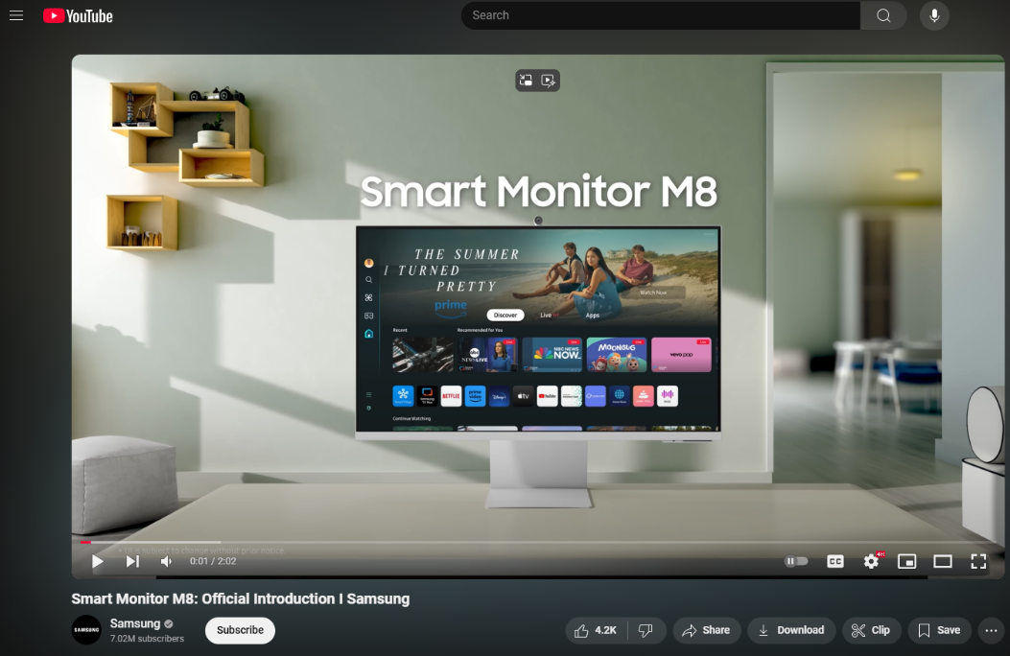

Figure 7: Reference image of Ad.

Video Link: <https://www.youtube.com/watch?v=6yBa_nrHFVc>

The Smart Monitor M8 ad does a good job of showing off the product's stylish look and wide range of uses. It does this by combining style and function with smooth changes that show off its features in real-life situations like streaming and work. Its bright colors and simple movements make it look better and make it easier for people to use. But the ad doesn't tell a story, has images that repeat, and uses text instead of voiceovers. Its clear images and creative transitions gave ideas for the advertisement of the company, which focused on interesting animations and smooth scene changes to show off their services well.

### 3.2 3D Explainer Video Animation

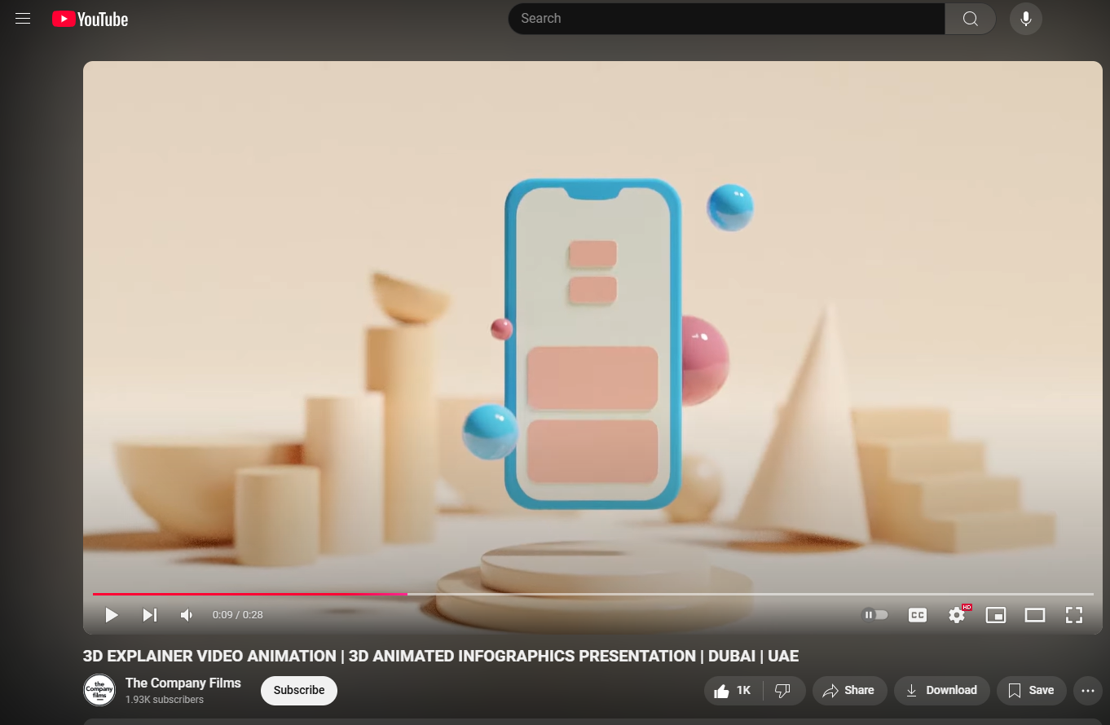Video Link: <https://www.youtube.com/watch?v=ZUXNCY2R5Wo>

Figure 8: Reference Image of Video.

The video looks great with its smooth transitions, clear voiceover, and enjoyable background music that sets a calm and professional mood. But its low-poly design doesn't go with the realistic look of the company’s idea. The slower pace and lack of interesting graphics also make it less exciting and dynamic. Even though the video has some problems, it is still inspiring because it shows how a simple approach and smooth transitions can successfully communicate a message while maintaining visual consistency. This is an idea that can be applied to the company’s services in a more interesting and realistic way.

### 3.3 SmartBug: Web Design and Development Service

Figure 9: Reference Image of a video.

Video Link: <https://www.youtube.com/watch?v=kSPKLJyspoc>

This advertisement for SmartBug's custom website design services used clean visuals and narration which shows professionalism and also engage viewers with the help of voiceover. It highlights flexibility and cost-effectiveness, aligning with their brand’s messaging. However, the video overuses the simple type of 3D animations style to display webpages, and also repeating the same style throughout the video, which makes it feel monotonous. Additionally, the advertisement is too lengthy which could cause viewers to lose interest. Taking Inspired from its clean design and voiceover, adding different types of engaging animations and keeping the length short would engage viewers while still showing Griptz's services.

## 4. Summary and Conclusions

The research process for creating the 3D advertisement for the company has been both insightful and helpful. By exploring elements like environment storytelling, motion graphics, and the rules of design, it made a foundation for crafting visually appealing and professional looking ad. The reviews of existing ads gave a valuable lesson about working with transitions, making clear visuals, and clear ways of delivering meaningful message.

This research makes sure that the final advertisement for the company will use new methods and interesting stories to make an ad that not only shows off the company’s services but also conveys messages to the audience.

# Section B: Project Proposal

## 5. Project Title

Working Title: Griptz Tech Advertisement

A 3D animated advertisement that shows the digital services offered by the company. The ad shows their skills at developing websites, mobile app, data analytics/market surveys and software maintenance. The 3D animated advertisement will show the company's dedication to providing brands with cutting-edge digital solutions that will helps them reach new customers.

## 6. Research Question

How can 3D animation creatively represent the services of a tech company while ensuring the advertisement is engaging and meets client expectations?

The project is all about using 3D animation to showcase a tech company’s services by combining dynamic visuals, smooth transitions, and stylized design. This approach highlights unique elements, such as modern workflows and innovative storytelling, to make the company's services stand out. Company’s services, like web development, mobile app solutions, and software maintenance, will be represented using stylized or realistic 3D elements. By using feedback from professionals and people and research animation methods will make the final result not only meets the client's goals but also connects with the target audience.

## 7. Treatment

### 7.1 Title

Griptz Tech Advertisement

### 7.2 Tagline

Your partner in the digital age.

### 7.3 Genres

Tech Advertising, Corporate, 3D Animation

### 7.4 Storyline

Showing different types of services that the company provides through 3D animations. It starts with web and mobile app development, followed by a market survey and data analytics. The advertisement concludes with software maintenance service and a final logo animation, showing how innovative and effective the company’s services are.

### 7.5 Target Audience

* **Industry type**: Startups, E-commerce, Healthcare, Education, Hospitality, Retail, Manufacturing, and Non-Profits.
* **Business Stage**: Growing Company, scaling or undergoing digital transformation.
* **Location**: Global.
* **People**: Decision-Makers likes CEOs, CTOs, IT Managers, and Marketing Heads.
* **Revenue Status**: $10K+ for larger enterprises.
* **Needs**: Digital services through websites, mobile apps, and IT solutions.
* **Tech Adoption**: Companies open to adopting digital services.

### 7.6 Experience

## 8. Resources

For making this advertisement, it requires few software, tools, assets and system requirement to make sure that all the process goes smoothly. Here is a list of those things required to complete the advertisement.

### 8.1 Software Overview

* **Autodesk Maya**: Used for creating 3D models, texturing, animation, lighting, and rendering.
* **Adobe Photoshop & Adobe Substance Painter**: Essential for detailed texturing of 3D models.
* **Adobe After Effects**: Applied for green screen tracking and motion graphics.
* **Microsoft Clipchamp**: Utilized to generate voiceovers.
* **Celtx**: Facilitates efficient scriptwriting.
* **Figma**: Used to design the website homepage for animation integration.
* **Adobe Premiere Pro**: Compiles rendered footage, soundtracks, and transitions to produce the final advertisement.

### 8.2 Hardware Requirements

* **Personal Computer**: Acer Nitro 5
* **Operating System**: Windows 11
* **Graphics Card:** Nvidia GeForce RTX 4060
* **Processor:** Intel Core i5 12th Gen
* **RAM:** 32 GB

### 8.3 Skills Required

* Motion Graphics
* Storyboarding
* 3D Modelling
* Storytelling
* Animating
* Texturing
* Scripting
* Lighting
* Editing
* Sound

### 8.4 Assets

* Realistic textures for models from Poly Haven or any other websites.
* Background music from Non copyright Sounds or other royalty free sound providing websites.
* Icons or PNG from icons8 or other websites.

## 9. Contribution of Others

### 9.1 Client

The client has contributed on the following things:

* **Concept Development**

The client played an active role in shaping the initial idea for the advertisement. They provided input on how the company’s services should be presented to ensure the concept aligned with their vision and goals.

* **Designs assets**

To maintain a consistent brand identity, the client shared key design elements such as their logo and few designs of websites. These assets helped give the advertisement a professional and cohesive look.

* **Feedback and Evaluation**

The client checked in on the project's progress at different points in its growth. Their comments and ideas helped refine the advertisement to better meet their standards and needs.

* **Insights into the target audience**

The client provided useful data and information about their audience, like what they like, what problems they're having, and what they expect. This information was very helpful in making the ad more appealing to potential clients.

* **Brand Guidelines**

The client provided clear instructions on how to incorporate their brand’s tone, style, and message. to make sure that the advertisement reflects the company's identity. These guidelines made sure that the final result fit with the company’s established image.

## 10. Evaluation and Testing

This advertisement will be presented to a targeted audience, particularly those interested in tech services. Along with the video, a Google Forms survey will be provided to collect feedback on the advertisement. Feedback will also be gathered from teachers to gain professional insights and ensure the project meets academic standards. Any necessary changes will be guided by the audience and teachers’ feedback, guaranteeing that the finished advertisement conveys the company’s services. The video will be improved through this feedback-driven process to meet the expectations of the client.